Analysis of the utilisation of idelalisib for refractory follicular B-cell non-Hodgkin's lymphoma

Drug utilisation sub-committee (DUSC)

October 2024

Abstract

Purpose
To review the utilisation of idelalisib for refractory follicular B-cell non-Hodgkin's lymphoma following amendments to the Pharmaceutical Benefits Scheme (PBS) Authority Required listing in January 2022.

Date of listing on the Pharmaceutical Benefits Scheme (PBS)
Idelalisib was listed on the PBS for refractory follicular B-cell non-Hodgkin's lymphoma on
1 September 2017.

Data Source / methodology
Authorities data and prescriptions data was extracted from the prescription database and
Authorities database maintained by the Department of Health and Aged Care, processed by
Services Australia from between 1 September 2017 and 30 June 2024. Data were extracted based on the date of supply.

Key Findings
- There were only a small number of patients being dispensed idelalisib for refractory follicular B-cell non-Hodgkin's lymphoma.
- The proportion of idelalisib for refractory follicular B-cell non-Hodgkin's lymphoma being prescribed by haematologists decreased since 1 January 2022 while the proportion being prescribed by pathologists increased.
- Fewer patients moved from the 150 mg dose to the 100 mg dose from 1 January 2022. And fewer patients commenced on the 150 mg dose and more on the 100 mg dose before transitioning to the 150 mg dose.
- Based on adverse event notifications from the Therapeutic Goods Administration (TGA), the most common adverse events associated with idelalisib treatment were infections and infestations, and gastrointestinal disorders.

Purpose of analysis

To review the utilisation of idelalisib for refractory follicular B-cell non-Hodgkin's lymphoma following amendments to the Pharmaceutical Benefits Scheme (PBS) Authority Required listing in January 2022.

Background

Clinical situation
Follicular lymphoma (FL) is the most common sub type of low grade (indolent or slow growing) lymphoma, making up 20-30% of all non-Hodgkin lymphomas.
FL is a B-cell lymphoma characterised by tumour cells that appear in a circular, or clump-like, pattern under the microscope. These irregular shaped follicles replace the normal structure of a lymph node.
FL is incurable and is characterised by substantial biochemical and clinical heterogeneity. As the most prevalent indolent lymphoma and the second most common non-Hodgkin lymphoma, it has a relapsing and remitting course with the potential to progress to aggressive disease. About 20% of the patients with follicular lymphoma develop disease progression within the first two years of chemotherapy, with an overall 5-year survival rate of 50%.

Pharmacology
Idelalisib inhibits phosphatidylinositol 3-kinase p110δ (PI3Kδ), which is hyperactive in B-cell malignancies and is central to multiple signalling pathways that drive proliferation, survival, homing, and retention of malignant cells in lymphoid tissues and bone marrow. Idelalisib is a selective inhibitor of adenosine-5’-triphosphate binding to the catalytic domain of PI3Kδ, resulting in inhibition of the phosphorylation of the key lipid second messenger phosphatidylinositol and prevention of Akt phosphorylation.
Idelalisib induces apoptosis and inhibits proliferation in cell lines derived from malignant B-cells and in primary tumour cells. Idelalisib inhibits homing and retention of malignant B-cells in the tumour microenvironment including lymphoid tissues and the bone marrow.

Therapeutic Goods Administration (TGA) approved indications
Idelalisib was registered on the Australian Register of Therapeutic Goods (ARTG) on
9 February 2015.
A boxed warning was added to the Product Information in April 2017 to alert prescribers of the risk of serious infections with specific reference to Pneumocystis jirovecii pneumonia and cytomegalovirus infection and also pneumonitis.
Idelalisib is currently TGA registered for the following indications:
- In combination with rituximab is indicated for the treatment of adult patients with chronic lymphocytic leukaemia (CLL)/small lymphocytic lymphoma (SLL) upon relapse in patients for whom chemo-immunotherapy is not considered suitable.
- In combination with ofatumumab is indicated for the treatment of adult patients with CLL/SLL upon relapse in patients for whom chemo-immunotherapy is not considered suitable*.
- As monotherapy for the treatment of patients with follicular lymphoma which is refractory to at least two prior systemic therapies. The disease must be refractory to both rituximab and an alkylating agent.
*Idelalisib in combination with ofatumumab for the treatment of adult patients with CLL/SLL upon relapse in patients for whom chemo-immunotherapy is not considered suitable is not a PBS listed indication.

Dosage and administration
The recommended dose of idelalisib for adults is 150 mg, taken orally, twice daily.
Dose modification is required for specific toxicities related to idelalisib.
The current Product Information (PI) and Consumer Medicine Information (CMI) are available from the TGA (Product Information) and the TGA (Consumer Medicines Information).

PBS listing details (1 July 2024)

Table 1: PBS listing of idelalisib for refractory follicular B-cell non-Hodgkin's lymphoma
Item | Name, form & strength, pack size | Max. quant. | Rpts | DPMQ | Brand name and manufacturer
11165P | Idelalisib 150 mg tablet, 60 | 1 | 5 | $5118.99 | Zydelig, Gilead Sciences Pty Limited
11171Y | Idelalisib 100 mg tablet, 60 | 1 | 5 | $5118.99 | Zydelig, Gilead Sciences Pty Limited
12812H | Idelalisib 150 mg tablet, 60 | 1 | 5 | $5118.99 | Zydelig, Gilead Sciences Pty Limited
12813J | Idelalisib 100 mg tablet, 60 | 1 | 5 | $5118.99 | Zydelig, Gilead Sciences Pty Limited

Source: the PBS website. A Special Pricing Arrangement is in place.
Note: Item codes as per 1 January 2022.

Restriction
Refractory follicular B-cell non-Hodgkin's lymphoma
Treatment Phase: Initial treatment
Clinical criteria:
The condition must be refractory to a prior therapy with rituximab within 6 months after completion of treatment with rituximab, AND
The condition must be refractory to a prior therapy with an alkylating agent within 6 months after completion of treatment with an alkylating agent, AND
The treatment must be the sole PBS-subsidised therapy for this condition.

The condition is considered refractory to a prior therapy when the patient experiences less than a partial response or progression of disease within 6 months after completion of the prior therapy.

The condition is considered refractory to both rituximab and an alkylating agent if the agents were administered together or in successive treatment regimens.

The date of completion of prior therapies with rituximab and an alkylating agent must be documented in the patient's medical records.

Note
No increase in the maximum quantity or number of units may be authorised.
No increase in the maximum number of repeats may be authorised.
Applications for authorisation under this restriction may be made in real time using the Online PBS Authorities system (see www.servicesaustralia.gov.au/HPOS) or by telephone by contacting Services Australia on 1800 888 333.

Treatment Phase: Continuing treatment
Clinical criteria:
Patient must have previously received PBS-subsidised treatment with this drug for this condition, AND
The treatment must be the sole PBS-subsidised therapy for this condition, AND
Patient must not develop disease progression while receiving PBS-subsidised treatment with this drug for this condition.

Note:
No increase in the maximum quantity or number of units may be authorised.
No increase in the maximum number of repeats may be authorised.

For details of the current PBS listing refer to the PBS website.

Date of listing on PBS
Idelalisib was listed on the PBS for refractory follicular B-cell non-Hodgkin's lymphoma on
1 September 2017.

Changes to listing
On 1 January 2022 the listing for idelalisib for refractory follicular B-cell non-Hodgkin's lymphoma was changed from Authority Required (Written) for initial treatment, and Authority Required (Telephone) for continuing treatment to Authority Required (Telephone) for initial treatment, and Authority Required (STREAMLINED) for continuing treatment.
Current PBS listing details are available from the PBS website.

Relevant aspects of consideration by the Pharmaceutical Benefits Advisory Committee (PBAC)
At its March 2016 meeting the PBAC deferred making a recommendation on the resubmission for idelalisib for the treatment of follicular lymphoma that is refractory to both rituximab and an alkylating agent. The PBAC noted recent global concerns about an increased rate of serious adverse events, including deaths, mostly due to infections in current on-going clinical trials studying idelalisib in combination with other medicines.
The sponsor was requested to update the PBAC on adverse events in the clinical areas in which listing was being sought, and if, or how, the recent emergence of additional serious adverse events in the current trials may impact patients if idelalisib became available in the broader PBS population.
For further details refer to the Public Summary Document from the March 2016 PBAC meeting.
At its July 2016 meeting the PBAC was provided with information regarding an emerging safety signal raised by the European Union and United States drug regulatory agencies and identified to the TGA in relation to idelalisib, and to clarify adverse events in the clinical area in which the listings are being sought. The PBAC recommended the Authority Required listing of idelalisib as monotherapy for the treatment of follicular B-cell non-Hodgkin’s lymphoma that is refractory to both rituximab and an alkylating agent.
For further details refer to the Public Summary Document from the July 2016 PBAC meeting.
On 19 April 2017 the TGA published a safety advisory in relation to the use of idelalisib in combination with rituximab for the treatment of relapsed indolent non-Hodgkin’s lymphoma.
For further details refer to the Safety advisory from the TGA.
At its November 2020 meeting the PBAC recommended an amendment to the PBS restriction level for idelalisib for the treatment of refractory follicular B-cell non-Hodgkin’s lymphoma to Authority Required (Telephone) for the initial treatment phase, and Authority Required (STREAMLINED) for the continuing treatment phase. The PBAC also recommended that DUSC review the utilisation of idelalisib for this indication in 12 months’ time due to safety concerns.
For further details refer to the Public Summary Document from the November 2020 PBAC meeting.
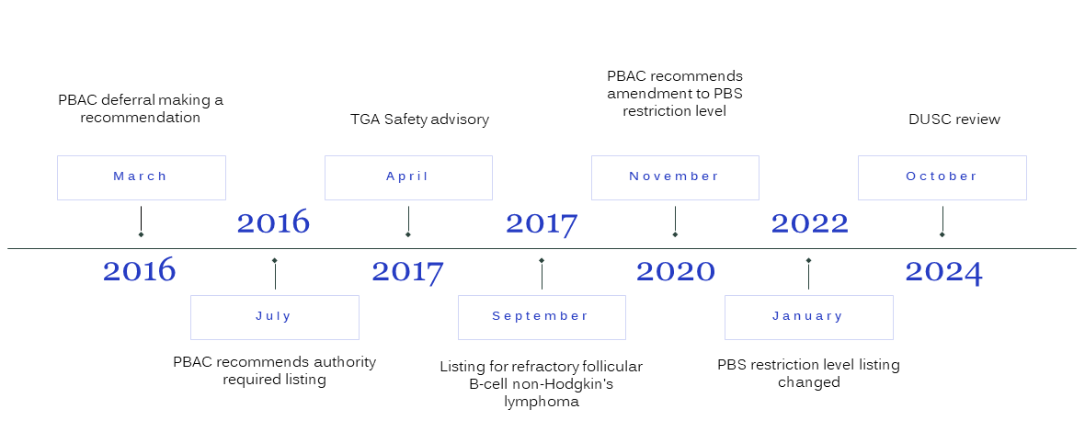
Figure 1: Timeline of the PBS listing process for idelalisib for refractory follicular B-cell non-Hodgkin's lymphoma

Methods
Authorities data and prescriptions data maintained by the Department of Health and Aged Care, processed by Services Australia, was extracted from 1 September 2017. Data was extracted based on the date of supply. Data is presented by financial year 1 July to 30 June.
Patient level analysis
The number of prevalent patients was determined by counting the number of people supplied at least one PBS prescription using person specific numbers (non-identifying) in the data for the specified time periods. Patient initiation was defined as the date of supply of the first PBS or RPBS prescription.
Treatment duration analysis
Time (days) on treatment was examined for all patients initiating idelalisib for refractory follicular B-cell non-Hodgkin's lymphoma with follow-up to the end of June 2024. Kaplan-Meier analysis was undertaken to analyse the time on treatment. Time on treatment was determined with and without treatment breaks.
Patients were assumed to have had a break in therapy if there was a period of no supply equivalent to three times the median time between supplies.
Patients who had a supply within 90 days of the analysis end date were assumed to be continuing on therapy. These patients were censored from the Kaplan-Meier analysis.
Prescriber analysis
Number and proportion of prescriptions dispensed by prescriber type over time was derived by specialities.

Adverse events analysis
Idelalisib is either dispensed as a 100 mg or 150 mg tablet depending on dose modification due to toxicities. Whether idelalisib was dispensed as a 100 mg or 150 mg table was determined by calculating the total amount of drug dispensed as the product of the mass per unit of drug supplied by the PBS quantity dispensed. Dose modification due to toxicity was taken as a proxy of adverse events.
Adverse event notifications in relation to idelalisib were accessed via the TGA’s Database of Adverse Event Notifications (DAEN).

Results

Analysis of drug utilisation

Overall utilisation
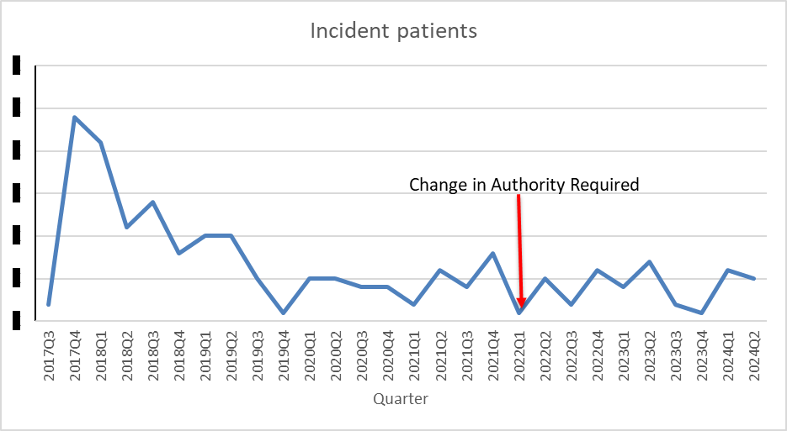
Figure 2: Trend in treated incident patients by quarter for idelalisib
Note:
Patient numbers have been redacted as numbers are small.

The arrow indicates the time (1 January 2022) when idelalisib for refractory follicular B-cell non-Hodgkin's lymphoma PBS listing changed from Authority Required (Written) for initial treatment, and Authority Required (Telephone) for continuing treatment to Authority Required (Telephone) for initial treatment, and Authority Required (STREAMLINED) for continuing treatment.
Prior to 1 January 2022 is henceforth referred to as ‘Pre’ while ‘Post’ refers to 1 January 2022 or after. Pre incident patients made up 79% of the incident population while post incident patients made up 21%.
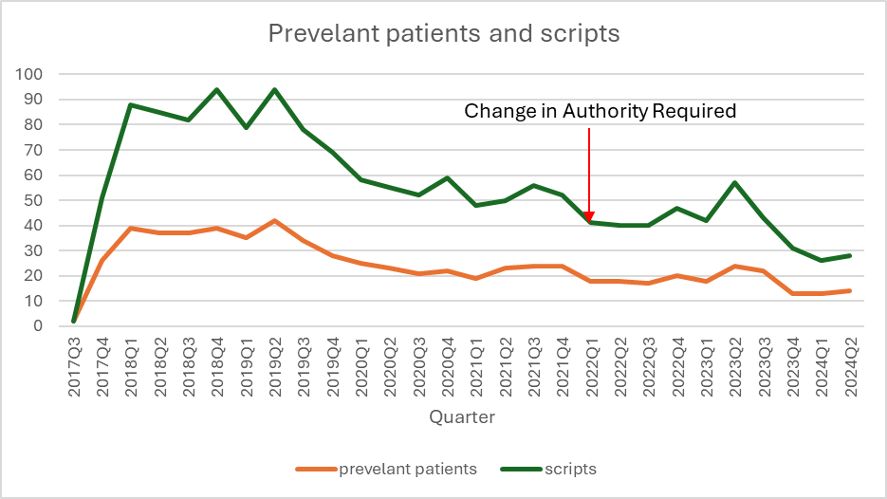
Figure 3: Number of treated prevalent patients and scripts by quarter for idelalisib

Time on Treatment

Table 2: Time on treatment (days) for idelalisib
 |  | With breaks | Without breaks
 | Pre
Mean |  | 296 | 188
Median |  | 130 | 90
 | Post
Mean |  | 251 | 192
Median |  | 167 | 94
 | Full time period
Mean |  | 300 | 178
Median |  | 130 | 89
The average length of treatment was longer for those patients being dispensed idelalisib for refractory follicular B-cell non-Hodgkin's lymphoma pre the restriction change while there were some patients staying on therapy longer post the restriction change.

Utilisation by relevant sub-populations/regions or patient level analysis
Table 3: Incident population by age and gender
Gender | Incident population | Mean age (years) | Median age (years) | Age range (years)
Males | 60% | 69 | 70 | 28 - 92
Females | 40% | 70 | 71 | 40 - 89

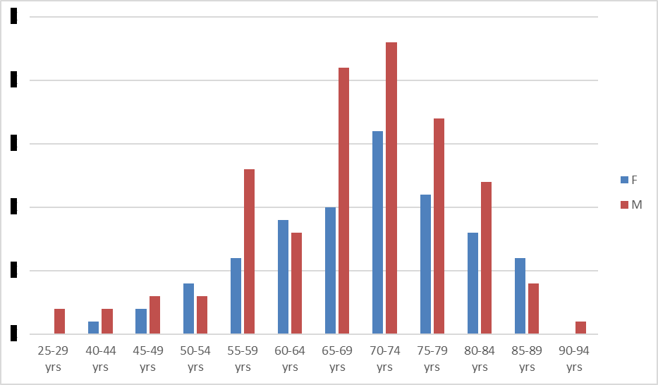
Figure 4: Incident patients of idelalisib by gender and 5-year age group
Note:
Patient numbers have been redacted as numbers are small.

More males than females were being dispensed idelalisib for refractory follicular B-cell non-Hodgkin's lymphoma, at a ratio of 3:2 which mirrored the incidence of non-Hodgkin’s lymphoma in the Australian population being 29.4 per 100,000 for males and 19.4 per 100,000 for females in 2019.

Prescriber analysis
Table 4: Percentage of prescriptions supplied by prescriber type
Prescriber type | Pre | Post
Haematology | 76.8% | 58.2%
Pathology | 8.1% | 25.8%
NONVRGP | 3.0% | 3.3%
VRGP | 1.2% | 3.0%
Internal Medicine | 0.2% | 3.0%
Medical Oncology | 3.6% | 3.0%
Not identified | 6.5% | -
Other | 0.7%¹ | 3.5%²
Note:
¹Includes GP unclassified (0.1%) and Paediatric Medicine (0.6%).
²Includes GP trainee (1.5%) and Paediatric Medicine (2.0%).
Pre consists of 75% of the prescriptions supplied.
Post consists of 25% of the prescriptions supplied.

Adverse events analysis
Table 5: Treatment sequence for dose modification due to toxicities
Treatment sequence | Pre | Post
150mg | 77.1% | 68.9%
100mg | 10.4% | 20.6%
150mg -> 100mg | 11.8% | 8.6%
100mg -> 150mg | 0.7% | 1.7%

Table 6: Number of adverse event reports
Year | Number of reports¹ | Prevalent patients
2015 | 3
2016 | 29
2017 | 10 | 26
2018 | 9 | 73
2019 | 6 | 59
2020 | 4 | 38
2021 | 1 | 38
2022 | 2 | 33
2023 | 7 | 29
2024 | 1 | 18
Note:
¹Cases were there was one or more medications being taken including idelalisib were there is a possibility that idelalisib caused the adverse event.
Source: TGA DAEN accessed 1 July 2024.
This data includes idelalisib use for all indications.

Table 7: Medicine summary of adverse events
¹MedDRA system organ class | Total number of cases² | Number of cases³
Blood And Lymphatic System Disorders | 13 | 3
Cardiac Disorders | 2 | 0
Endocrine Disorders | 1 | 0
Gastrointestinal Disorders | 14 | 12
General Disorders and Administration Site Conditions | 34 | 18
Hepatobiliary Disorders | 5 | 5
Infections And Infestations | 42 | 14
Injury, Poisoning and Procedural Complications | 3 | 3
Investigations | 8 | 7
Metabolism And Nutrition Disorders | 5 | 3
Musculoskeletal And Connective Tissue Disorders | 1 | 0
Neoplasms Benign, Malignant and Unspecified (Incl Cysts and Polyps) | 7 | 2
Nervous System Disorders | 1 | 0
Psychiatric Disorders | 2 | 0
Renal And Urinary Disorders | 8 | 4
Respiratory, Thoracic and Mediastinal Disorders | 8 | 2
Skin And Subcutaneous Tissue Disorders | 12 | 7
Total Cases | 166 | 80
Note:
Source: TGA DAEN accessed 1 July 2024.
¹A description of the type of adverse event classified mostly according to a specific part of the body in the Medical Dictionary for Regulatory Activities (MedDRA).
²The number of cases in which the adverse event was listed.
³Number of case when idelalisib is the only product suspected to be related to the adverse event.
This data includes idelalisib use for all indications.

Discussion
There were only a small number of patients being dispensed idelalisib for refractory follicular B-cell non-Hodgkin's lymphoma (this is mirrored in the small number of patients being dispensed idelalisib in combination with rituximab for CLL/SLL).
Given the low number of patients being dispensed idelalisib for refractory follicular B-cell non-Hodgkin's lymphoma and the low number of adverse events reported it was difficult to draw any firm conclusions regarding changes in its safety profile post the changes to the PBS restriction beginning on 1 January 2022. However, it was possible to draw out some general trends.
The proportion of idelalisib for refractory follicular B-cell non-Hodgkin's lymphoma being prescribed by haematologists (Table 4) significantly decreased post the restriction changes while the proportion being prescribed by pathologists significantly increased. Along with small changes in other prescribing patterns this could indicate that there was an increase in the number of scripts being written by specialist with less experience in the treatment of follicular B-cell non-Hodgkin's lymphoma following the restriction change.
While fewer patients moved from the 150 mg dose to the 100 mg dose (Table 5) following the change in the restriction indicating fewer treatment related toxicities, fewer patients commenced on the 150 mg dose and more on the 100 mg dose before transitioning to the 150 mg dose. This may indicate some caution by prescribers to commence patients on the 150mg dose.
Apart from “general disorders” the most common adverse events associated with idelalisib treatment are infections and infestations, and gastrointestinal disorders. The Product Information contains a boxed warning in relation to idelalisib causing serious infections.
DUSC consideration
DUSC noted that the number of treated patients was very small. DUSC considered there had been no significant change in patient numbers since the change in restriction.
DUSC noted the change in the pattern of prescriber type since the change in restriction. DUSC did not consider that this represented a significant shift in the pattern of prescribing as many haematologists also hold accreditation as pathologists. DUSC considered that the observed change in the pattern of prescribing was more likely a coding issue as opposed to any significant change in prescriber behaviour.
DUSC noted the difference in the median time on treatment since the change in restriction. DUSC considered that the time differences were likely to be non-significant and reflect patients becoming more familiar with the drug. DUSC noted that the difference in median times on treatment may be an artifact of the small numbers of patients and different lengths of time the medication has been on the market prior to the restriction change (over 4 years) and after (2.5 years) the restriction change.
DUSC noted that the US Food and Drug Administration withdrew approval of idelalisib for the indications of relapsed follicular lymphoma and relapsed small lymphocytic lymphoma after the sponsor made a request for a voluntary withdrawal. DUSC noted that idelalisib still had marketing approval from the European Medicines Agency. DUSC considered that there may still be some Australian patients who are reliant on idelalisib and that it was appropriate for idelalisib to remain available in the Australian market.
DUSC noted the change in the treatment sequence for dose modification prior and after the restriction change. DUSC considered that this change was mainly due to patient and prescriber familiarity with the medication.
DUSC noted the small number of reported adverse event reports and the trend to fewer events over time. DUSC considered this reflected improved prescriber and patient familiarity with the medication.

DUSC Actions
DUSC requested that the report be provided to the PBAC for consideration.

Context for analysis
The DUSC is a Sub Committee of the Pharmaceutical Benefits Advisory Committee (PBAC). The DUSC assesses estimates on projected usage and financial cost of medicines.
The DUSC also analyses data on actual use of medicines, including the utilisation of PBS listed medicines, and provides advice to the PBAC on these matters. This may include outlining how the current utilisation of PBS medicines compares with the use as recommended by the PBAC.
The DUSC operates in accordance with the quality use of medicines objective of the National Medicines Policy and considers that the DUSC utilisation analyses will assist consumers and health professionals to better understand the costs, benefits and risks of medicines.
The utilisation analysis report was provided to the pharmaceutical sponsors of each drug and comments on the report were provided to DUSC prior to its consideration of the analysis.

Sponsors’ comments
Gilead Sciences Pty Limited. The sponsor had no comment.

Disclaimer
The information provided in this report does not constitute medical advice and is not intended to take the place of professional medical advice or care. It is not intended to define what constitutes reasonable, appropriate or best care for any individual for any given health issue. The information should not be used as a substitute for the judgement and skill of a medical practitioner.
The Department of Health and Aged Care has made all reasonable efforts to ensure that information provided in this report is accurate. The information provided in this report was up-to-date when it was considered by the Drug Utilisation Sub-committee of the Pharmaceutical Benefits Advisory Committee. The context for that information may have changed since publication.
To the extent provided by law, the Department of Health and Aged Care makes no warranties or representations as to accuracy or completeness of information contained in this report.
To the fullest extent permitted by law, neither the Department of Health and Aged Care nor any Department of Health and Aged Care employee is liable for any liability, loss, claim, damage, expense, injury or personal injury (including death), whether direct or indirect (including consequential loss and loss of profits) and however incurred (including in tort), caused or contributed to by any person’s use or misuse of the information available from this report or contained on any third party website referred to in this report.

References
Leukaemia Foundation (2024) Follicular lymphoma. https://www.leukaemia.org.au/blood-cancer/types-of-blood-cancer/lymphoma/non-hodgkin-lymphoma/follicular-lymphoma/. Accessed 27 June 2024.
ZYDELIG® (idelalisib). Australian Approved Product Information. Gilead Sciences Pty Ltd. Approved 9 February 2015, updated 30 April 2024. Available from https://www.ebs.tga.gov.au/ebs/picmi/picmirepository.nsf/pdf?OpenAgent&id=CP-2015-PI-01225-1&d=20240725172310101
Singh D, Singh A, Mukkamalla SKR. Relapsed and Refractory Follicular Lymphoma. [Updated 2023 Jan 15]. In: StatPearls [Internet]. Treasure Island (FL): StatPearls Publishing; 2024 Jan-. Available from: https://www.ncbi.nlm.nih.gov/books/NBK589677/. Accessed 27 June 2024.

Source – Australian Institute of Health and Welfare, Cancer data in Australia, https://www.aihw.gov.au/reports/cancer/cancer-data-in-australia/contents/cancer-incidence-by-age-visualisation, accessed 19 July 2024.
Drug Utilisation Sub Committee (DUSC) public release document - Analysis of venetoclax for first-line treatment of chronic lymphocytic leukaemia or small lymphocytic lymphoma, September 2023, accessed 23 July 2024.

